[CULTURE](https://fashionmagazine.com/category/culture/) / [POPULAR](https://fashionmagazine.com/category/popular/)

Introduction to Tarot Cards: Breaking Down the Meaning of Each Symbol

Working with your higher self

**How did tarot card readings start?**  
Guide to self-empowerment as imaged through 78 symbolic cards.

**How do tarot cards work?**  
Psychologist Carl Jung established a synchronicity of the cards which is the choice of a card as exactly what your higher self already knows.

**Types of decks**  
22 Major Arcana - archetypal images

56 Minor Arcana cards:

16 Court or Personality cards: Kings, Queens, Princes and Pages,

4 elements or suits: Fire, Earth, Air and Water, with 10 cards in each.

There are no inherently negative cards.

**The High Priestess**

Feelings, instincts and emotions.

**The Magician**

The messenger, your imagination.

**The Fool**

The Fool is the wisest one, the inner child.

**The Empress**

Money, peacemaking and the arts.

**The World**

The real everyday world.

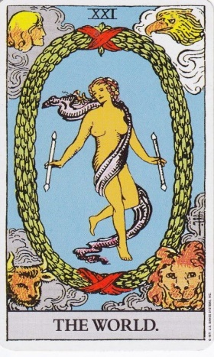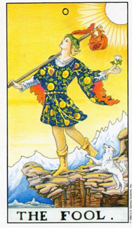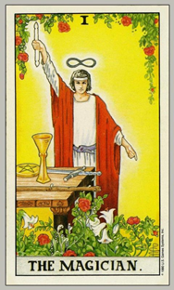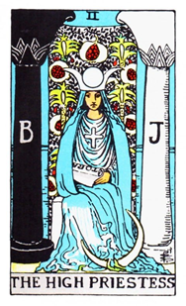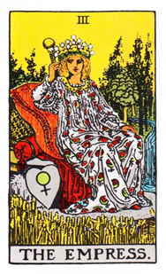

**The Chariot**

Home, family, needing emotional protection, your mother, nurturing, caring and nourishment.

**The Lovers**

**Heaven and earth, union, love, communication, balance, and duality.**

**Justice**

Relationships, finding peace, self and others, marriage.

**The Emperor**

New beginnings, competition & aggressiveness.

**The Hierophant**

Grounded, practical wisdom and energy.

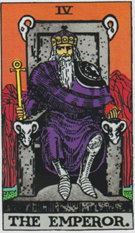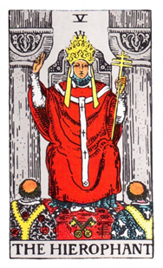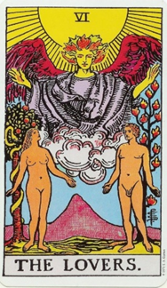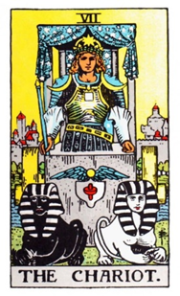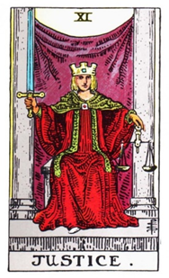

**Death**

Power, control, the unconscious, psychology, sexuality and fear.

**The Wheel of Fortune**

Generosity, freedom and taking risks. It is lucky, but can mean too much of a good thing.

**Strength**

Symbolizes the courage in your heart.

**The Hanged Man**

Scapegoating and martyrdom.

**The Hermit**

It is intelligent, analytical and self-critical.

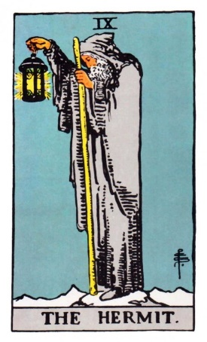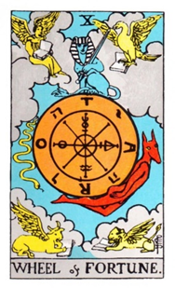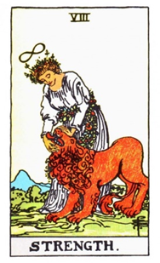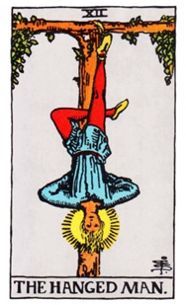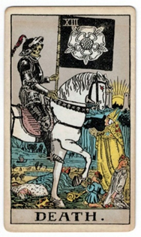

**The Moon**

Relying on your intuition and working with your dreams.

**The Star**

Aquarius, detachment, inventiveness connecting you to astrology.

**Temperance**

Optimism, higher knowledge, wisdom and truth.

**The Tower**

Brings sudden, shocking awareness, accidents and losses.

**The Devil**

Your shadow, dark side and unconscious mind.

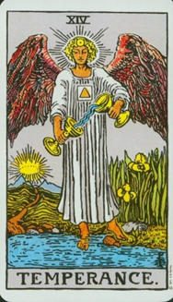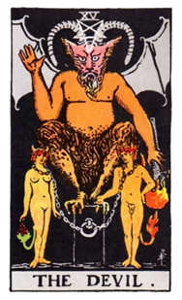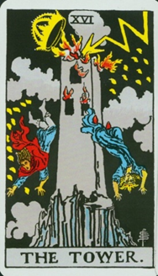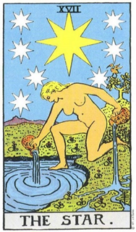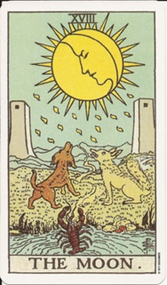

**The Sun**

Living in the light, positive energy, warmth, happiness, joy, dancing, celebration, ecstasy.

***Your reading today as it relates to your Academic future***

Feelings:________________________________________________

Influences:______________________________________________

Emotional Block:__________________________________________

Expectations:_____________________________________________

Most likely Outcome:_______________________________________

_________________________________________________________

You can do it from Start to Finish, You are the Master of your Pathway to Success!

**Judgement**

Resurrection, change, freedom from the past, and grace.





