Association of Florida Colleges
Outstanding Chapter of the Year
Platinum Chapter, Gold Chapter, and Silver Chapter Distinctions.
Period of Award: June 1, 2018 – May 31, 2019

ACTIVITIES SUBMITTED FOR JUDGING

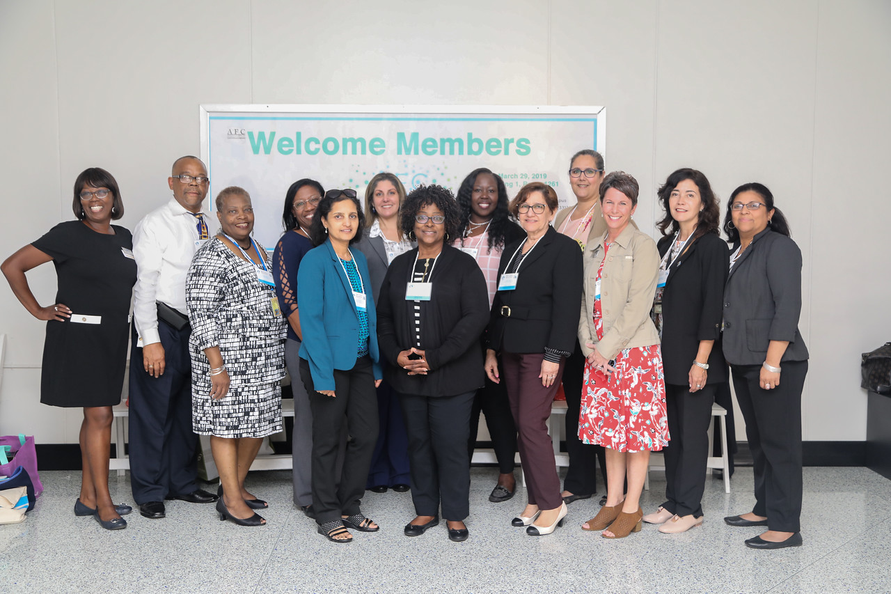

Complete and submit this form with your nomination. Please fill out the form entirely. Attach additional pages as necessary. Nominations must be submitted to the Awards Committee Chair by July 31. See the Standing Committees section of the AFC Leadership Manual for address information.

COLLEGE: Miami Dade College ADDRESS: 11011 SW 104 St

CITY: Miami STATE: FL ZIP: 33176

CHAPTER PRESIDENT: Mark Johnson E-MAIL ADDRESS: mjohnso2@mdc.edu

CHAPTER PRESIDENT’S PHONE: 305-237-1649

- Membership (Unlimited Points)

Points will be calculated for new members and member retention
NEW MEMBER POINTS – Excluding Trustees/Contributing

Chapters will earn points for new members enrolled during the period of June 1 – May 31:
• Each new full-time member acquired: 1 (one) point - excludes trustees, contributing,
part-time, adjuncts, and retirees. 21 new members Jan. - June 2019
• Each new adjunct or part-time member acquired: .50 (half) point 6 new adjuncts
• New retiree (retiree or life retiree): .25 (quarter) point RETENTION BONUS POINTS
Excluding

Trustees/Contributing Chapters will earn bonus point for the % of retained members:
• 90% or more members retained: 5 points
• 75% - 89% of members retained: 2 points = 83%
• 74% or less of members retained: 0 points
Each year AFC State Office will provide the previous year’s total membership #407

See Attachment A

TOTAL POINTS AWARDED FOR MEMBERSHIP _____24___ points

- State Leadership (Maximum 30 points) (2 points each)

Names of candidates for State, Region, or Commission Office:

Names of state officers as of June 1st, 2019-Period of 2018-2019
AFC LEGISLATIVE COMMITTEE http://www.myafchome.org/afc-advocacy
Victoria Hernandez, Director of Governmental Affairs at Miami Dade College -2019

All terms begin January 1. http://www.myafchome.org/committees#MemberDev

Membership Development Committee of Region V
Wanda Curtiss, Chair MDC; eMail: wcurtiss@mdc.edu; Phone: 305-237-8969

Region V Chapters Director
Director: Mark Johnson, Miami Dade College

Equity, Diversity and Inclusion Commission
Chair: Daniella Pierre, MDC; eMail: dpierre@mdc.edu; Phone: 305-237-1503

Campus Safety
Chair Elect: Yakir Fernandez, MDC: eMail, Yakir yfernan5@mdc.edu Phone: 305-237-2653

Retirees Committee
Secretary: Bertha Cabrera, MDC; eMail: bcabrera@mdc.edu; Phone: 305-237-8468

Technology Commission
Vice Chair: Eleazar, MDC; eMail: easencio@mdc.edu; Phone: 305-237-6259

Trustees Commission
Immediate Past Chair: Marili Cancio, MDC; eMail: marili.cancio@cjelaw.com; Phone: 305-200-8696 (was not considered in past yearbook)

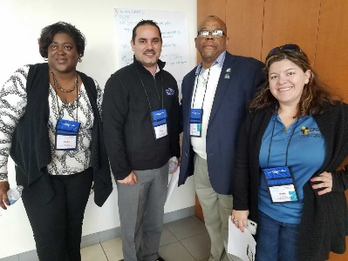

TOTAL POINTS AWARDED FOR STATE LEADERSHIP 16 points

- State, Region, and Commission Participation (Maximum 50 points)

  - Attendance at Safety Symposium
Yakir Fernandez, Chair-Elect Safety Commission 1 point

  - Attendance at Leadership Conference
Mark Johnson, AFC MDC Chapter President and Region V Director 1 point
Wand Curtiss, State Membership Co-Chair 1 point
Yakir Fernandez, Chair-Elect 1 point

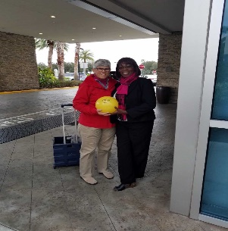

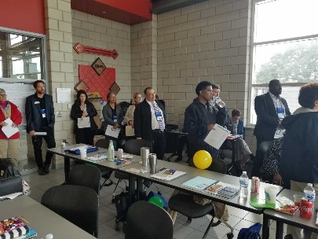

Sandi and Wanda at the Leadership Conference along other members at the conference January/February 2019

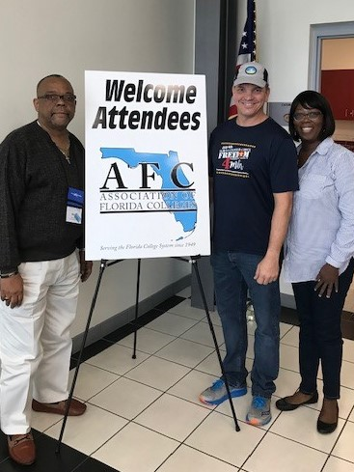

Mark, Ray, and Wanda at the January AFC Board Meeting
And Leadership Conference at Seminole State College

Attendance at Annual Conference – see Attachment B

  - Dr. Julie Alexander, Associate Provost 1 point
Wanda Curtiss, State Membership Co-chair 1 point
Mark Johnson, Region V Director 1 point
Daniella Pierre, Chair Equity Diversion & Inclusions Comm. 1 point
Dr. Lenore Rodicio, Vice President and College Provost 1 point

AFC Officers at the Annual Conference in Orlando, FL
November 2018

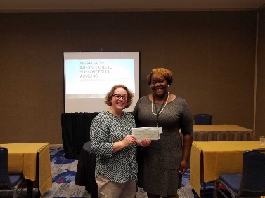
Annual Conference in Orlando, FL
November 2018
Equity Award Winner Daniella Pierre

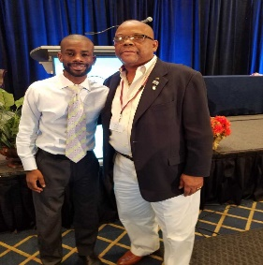
Mark Johnson and the Guest Speaker at the Annual Conference
Orlando, FL 2018

c. Submittal of Chapter Activity Reports to Region Director – (see
Attachment C)
d. Attendance at Region V Conference – see Attachment D
Mark Johnson
Carol Wynter
Denise Mera
Liliana Ramirez
Theresa Jones 5 points
e. Attendance at Chapter Presidents’ Meetings – (see Attachment E) 3 points
f. Attendance Commission Conference – Student Services Commission
Conference
Daniella Pierre, Equity Commission 1 point
Mark Johnson, Student Services Commission 1 point

(see Attachment F)
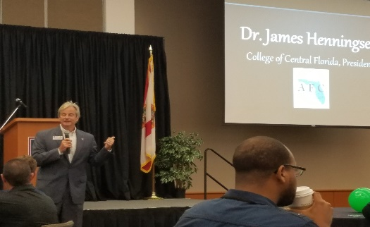
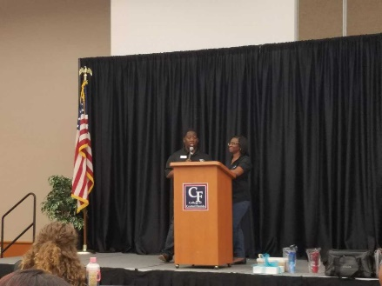

g. Attendance at AFC’s 2019 Conference on College Teaching and
Learning Conference
Miriam Abety 1 point
Nyaesia Campbell 1 point
Annette Zayes 1 point
See Attachment H

h. Attendance at Membership Conference/Workshop – see attachment D
Wanda Curtiss, State Membership Co-chair 2018 1 point
See Attachment G
i. Attendance at Board of Directors – see Attachment I
January Meeting - Mark Johnson and Wanda Curtiss 2 points
May Meeting – Mark Johnson and Daniella Pierre 2 points
TOTAL POINTS AWARDED FOR STATE, REGION & COMMISSION PARTICIPATION 27 points

- Commission Exemplary Practices (Max. 90 points)

(See Attachment J)

  - AFC EXCELLENCE AWARD/ 2019 Aspen Prize Finalists-MDC
  - 018-2019 MDC Kendall Campus Learning Resources team for winning the AFC LR Commission’s Exemplary Practice Award in the Learning Support Services category for their collaboration with the English department.
  - Presenters: Learning Resources- Making Connections presented by Nora Morales, Leslie Alfonso, and Charles Meehan of Miami-Dade (Kendall)
Presentation from the LRC Virtual Conference found here: https://irsc.libguides.com/virtualconference/Connections
  - Learning Resource Commission Exemplary Practice
TOTAL POINTS AWARDED FOR COMMISSION EXEMPLARY PRACTICES 30 points

- Chapter Political Activities (Maximum 20 points)

See Attachment K

  - Name of Activity: Miami Dade College-wide AFC Legislative Committee - MDC Chapter President
  - Name of Activity: Miami Dade College Legislative Trip to Tallahassee, FL to meet State Representatives and Senators.
  - Name of Activity: AFC and the NAACP Voter Drive and Town Hall Meeting
  - Name of Activity: 9/11 Honoring Freedom a Tribute to men and women who have served our Country college-wide September 2019.
  - Name of Activity: The Support Staff Council and the AFC Chapter at the Inter-American Campus together hosted a Lunch and Discussion for the Vote Together Challenge #VoteTogether Challenge - November 1, 2018

Chapter Political Activities
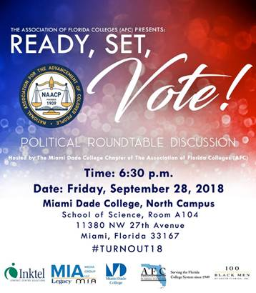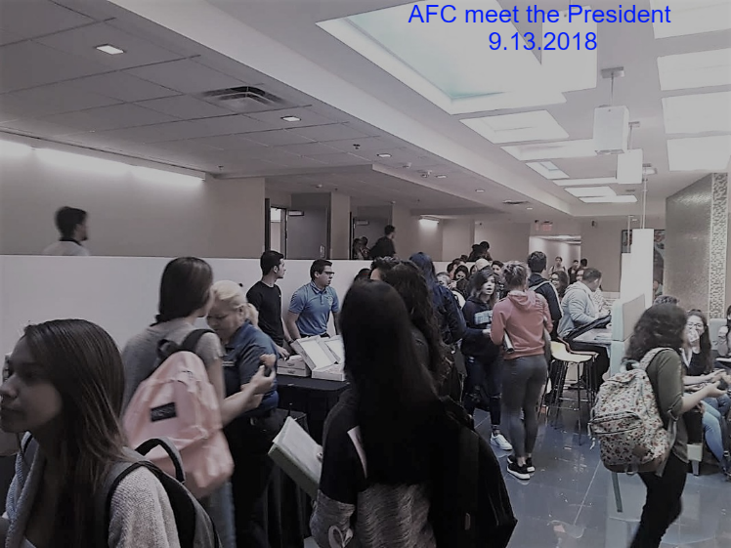

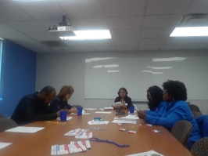
Support Staff Meets for Voter Registration Drive
September 2018
  - Name of Activity: LEGISLATIVE UPDATE by Ms. Victoria Hernandez on March 29, 2019. See Region V Spring Conference Program
  - Name of Activity: Daniella Pierre on Twitter on the ongoing Housing Crisis (social-political issue) posted on The Miami Times where Daniella Pierre is a contributor.
MDC AFC Members advocating for fair housing/
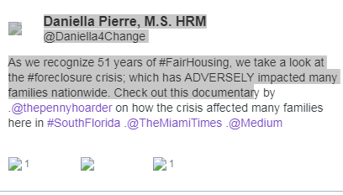

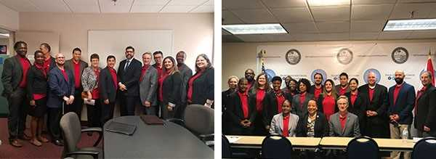

AFC Members on the Legislative Committee Visit Tallahassee, FL with Elected Officials
February 2019

TOTAL POINTS AWARDED FOR CHAPTER POLITICAL ACTIVITIES 35 points

- PROFESSIONAL DEVELOPMENT ACTIVITIES BY CHAPTER (max 20pts) (5 points each )

Below we are listing the following PDA by Commission, Presenter, and workshop. These PDA were held at the Region V Conference hosted by MDC at Wolfson Campus on March 28-29, 2019.

  - Name of Activity: Career and Professional Employees-Gregory Williams-Servant Leadership

  - Name of Activity: Dade County Library-Dillon/Leyva/Hernandez/Torralbas-Play On! Bringing Gaming into the Classroom

  - Name of Activity: Ms. Marjorie McGee-AFC Development for Leaders

  - Name of Activity: Technology-Michael Pelitera/Paul Lefavi-Using Video and Screen Capturing Tools

  - Name of Activity: Equity Diversity & Inclusion-Daniella Pierre-What Time Is It?

  - Name of Activity: Facilities-John Barbieri/Govindah Ramnarian-Connecting the Dots between College Facilities & Student Success

  - Name of Activity: Mets & Talk – The Impact of Technology on Education & Business

See Attachment L

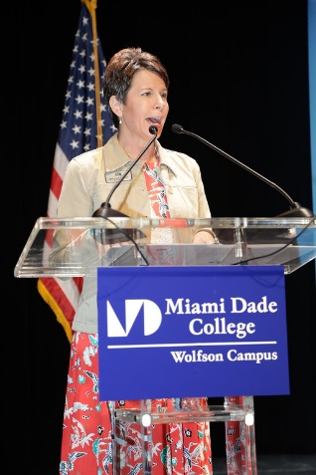

TOTAL POINTS AWARDED FOR PROFESSIONAL DEVELOPMENT _20_____ points

7. MEMBERSHIP DEVELOPMENT ACTIVITIES BY CHAPTER (max 20pts) (5 points)
See Attachment M

- Name of Activity: 2019 AFC Induction Ceremony & Membership Development on January 2019.
- Name of Activity: Membership-Ms. Wanda Curtiss-The Membership Connection presented at the MDC Region V Conference on March 29, 2019.
- AFC MDC West Membership Online Campaign and Digital Display
- Miami Dade College West Campus has an Ongoing recruiting campaign of new adjuncts in Academic Affairs by placing an invitation letter and a membership application in each mailbox for their consideration.
- Digital displays of AFC Membership screen flyer on Campus TVs.
- Name of Activity: AFC luncheon with Dr. Rodicio Jul19.2018 @ Wolfson

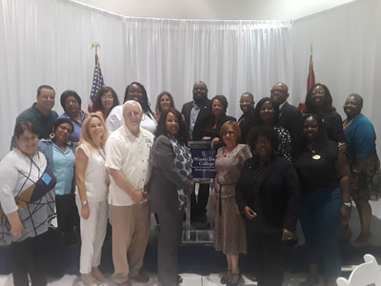
AFC Appreciation Luncheon AFC Officers Induction Cermony
July 2018 February 2019

- Name of Activity: AFC Halloween Tarot Reading & AFC Membership Recruiting Event
Title: Academic Ghostly Tarot Reading
Coordinated by: Bertha Cabrera, AFC VP West
Session #7 – Room # 2121
Date: October 31, 2018
Hours: 6 pm & 8 pm

Tarot Reading Tarot Reading

TOTAL POINTS AWARDED FOR MEMBERSHIP DEVELOPMENT ACTIVITIES _20_ points

8. COMMUNITY SERVICE ACTIVITIES BY CHAPTER (max 26pts)
a. Name of Activity: 2018 End Homelessness Campaign ongoing.

Partnership with the Homelessness and AFC
b. Name of Activity: Care Closet donation MDC West ongoing collaboration
Student Life

c. Name of Activity: Kilpatrick’s Kloset and Food Pantry
: 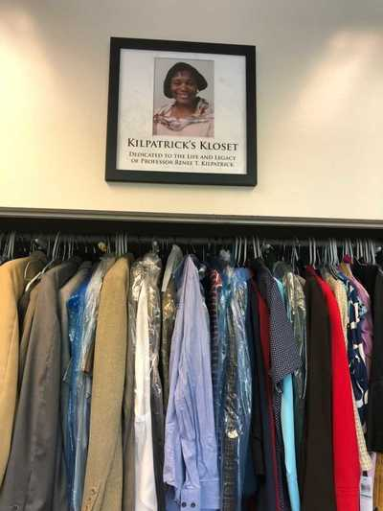
Community Service Project
.
Food Pantry Donations at West Campus July 18, 2018

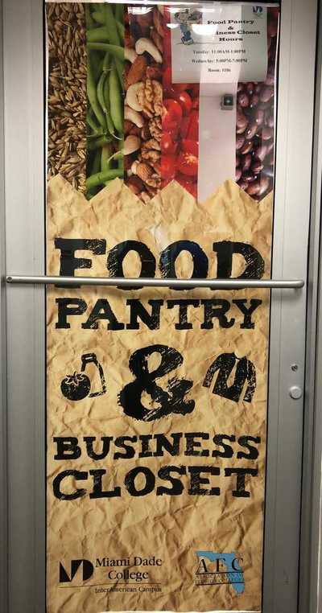
Food Pantry at Eduardo J. Padron’ Campus

- Name of Activity: Stop the Violence April 2019

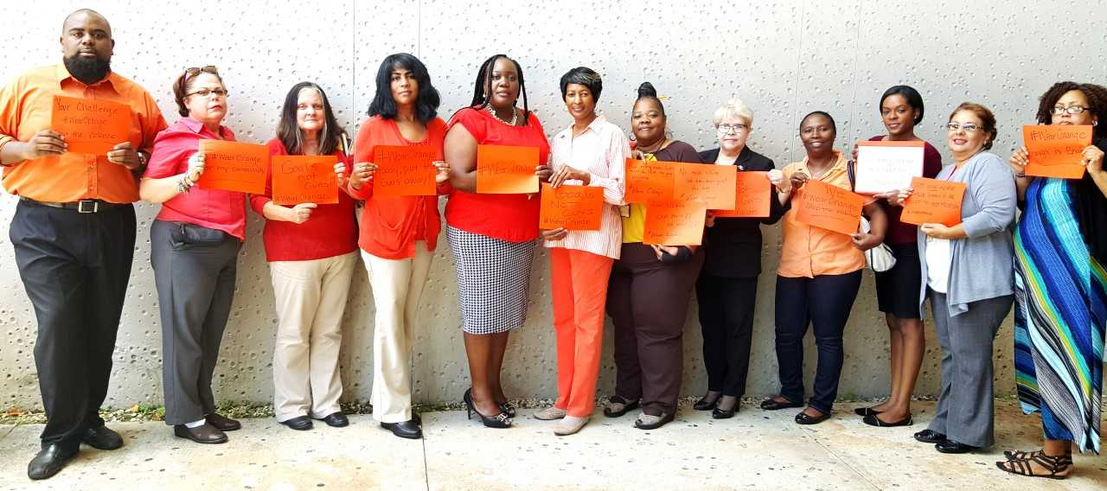

AFC Members Supporting the Stop the Violence at North Campus

- Name of Activity: AFC supporting the United Way college-wide ongoing every year.

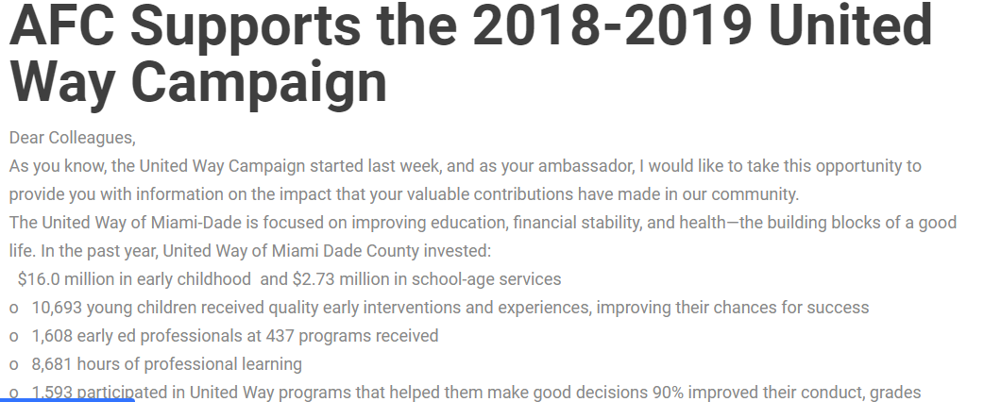

- Name of Activity: The 2019 Region V Conference Community Service Project will benefit the students at Stellar Leadership Academy on March 28-29, 2019.

- Name of Activity: the AFC West is accepting campus-wide donations for the "Give Kids the World Village" in addition to promoting the Hurricane Michael's relief link: https://www.myafchome.org/afc-member-hurricane-relief

TOTAL POINTS AWARDED FOR COMMUNITY SERVICE ACTIVITIES ____28_ points

9. SOCIAL ACTIVITIES BY CHAPTER (max 20pts)

  - Name of Activity: Ongoing every fourth Friday of every other Month at 5pm – You are all invited! RSVP bcabrera@mdc.edu Cell. 305-794-6930 Office: 305-237-8468
  - Name of Activity: AFC Annual Holiday Party

  - Name of Activity: Region V Social gathering network on March 28, 2019 at 6:30 pm - 9:30 pm Largo Bar & Grill Seafood Restaurant - Bayside Miami, FL

  - Name of Activity: Tour to San Agustin co-sponsored with Rhyna Moldes, CEO Cultural and Community Association on December 8-9, 2018.

  - Name of Activity: Hard ROCK Association night co-sponsored with Miami Dade Dolphins on August 2, 2018.
  - Name of Activity: Welcome Back Meeting and Ice Cream Social

Welcome Back and Ice Cream Social at North Campus

TOTAL POINTS AWARDED FOR SOCIAL ACTIVITIES
20_ points

10. FUNDRAISING ACTIVITIES BY CHAPTER (Maximum 5 points)
Name of Activity: Region V Fundraising
Several MDC AFC members were successful in raising $1,250.00 to donate to to Region V 2019 Spring Conference. See Region V – Vendor’s List

TOTAL POINTS AWARDED FOR FUNDRAISING ACTIVITIES
5 points

11. SCHOLARSHIP PROGRAM PROVIDED BY AFC
CHAPTER (Maximum 5 points)

- Established Scholarship Program @ IAC & WEST
https://afcmdc.weebly.com/about-us.html
TOTAL POINTS AWARDED FOR SCHOLARSHIP ACTIVITIES
___5___ points

12. Social Media (max 30 points)

- Weebly: http://afcmdc.weebly.com Webpage: http://www.mdc.edu/afc/
- SharePoint: https://sharepoint.mdc.edu/north/committees/facc/SitePages/Home.aspx
- Private New Sandbox on BB: https://mdc.blackboard.com/
- Twitter #Region V and #mdcAFC
- #VoteTogether Challenge

TOTAL POINTS AWARDED FOR SOCIAL MEDIA ACTIVITIES
__30____ points

13. CERTIFIED COLLEGE PROFESSIONAL (CCP)
PROGRAM (unlimited points)

Name of CCP Candidate to Graduate: Adolfo Mendez, MDC West Adjunct
Graduate date:
Sessions Attended:

TOTAL POINTS AWARDED FOR CCP ACTIVITIES _2___ points

14. PUBLICIZING CHAPTER ACTIVITIES (max 10 points)

1)-Article title and dates – Testimonial of Danielle Pierre, MDC on AFC Brochure file:///C:/Users/Administrator.CUSTSVCMETRICS.000/Documents/AFC/2019/AFC_Brochure_2019.pdf 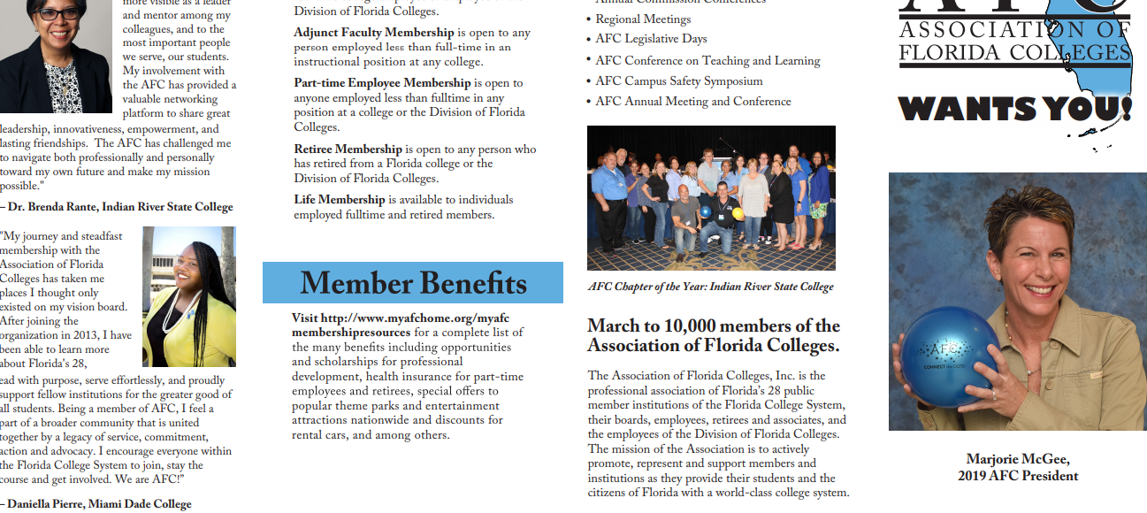

TOTAL POINTS AWARDED FOR PUBLICIZING CHAPTER ACTIVITIES _10_____ points

15. CHAPTER ORGANIZATION (Maximum 20 points)
(see Attachment O)
Chapter By-laws: Reviewed June 6, 2019
Minutes from Chapter Officer Meetings: September 26, 2018

Minutes from Chapter member meetings: December 5, 2018

Strategic Plan: AFC Operation Plan

TOTAL POINTS AWARDED FOR CHAPTER ORGANIZATION
20 points

16. COLLEGE RETIRED MEMBERS ACTIVITIES (Maximum 15
points)
a. College Retired Members Contact List (provided by Tallahassee)
b. Publicizing of Chapter Activities to College Retirees: see AFC Circle, Webpage
https://afcmdc.weebly.com/about-us.html
- http://www.myafchome.org/index.php?option=com_content&view=article&id=252:myafcretirees&catid=21:commissions&Itemid=250
- https://afcmdc.weebly.com/retirees-committee--circle.html
- Attending Retirees Committee Meetings: February 1, 2019, March 1, 2019 & April 18, 2019.
- AFC Retiree honored with the Change Maker Award
- AFC Retiree presented at the Region V Spring Conference March 28, 2019
- AFF Retiree publicized at the AFC Retirees Committee in the conference program

(see Attachment P)

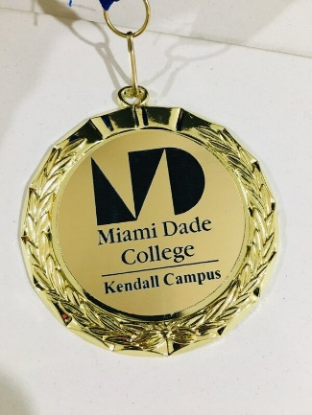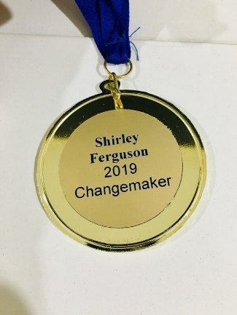
Retiree Shirley Ferguson honored as a “Change Maker” at the Martin Luther King Day Celebration at the Kendall Campus in January 2019

TOTAL POINTS AWARDED FOR RETIRED MEMBERS
15 points

APPENDIX
- Attachments A thru P
- Region V Spring Conference Pictures

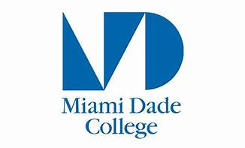

Miami Dade College, Wolfson Campus
300 N. E. 2 Avenue
Miami. FL 33132

Miami Dade College
District Board of Trustees

Bernie Navarro, Chair
Jose K. Fuentes, Vice Chair
Dr. Anay Abraham
Michael Bileca
Marcell Felipe
Benjamín León III
Carlos Migoya
Nicole Washington

Dr. Eduardo J. Padrón, President, Miami Dade College

Miami Dade College is an equal access/equal opportunity institution and does not discriminate
on the basis of sex, race, color, marital status, age, religion, national origin, disability veteran’s, status, sexual orientation or genetic information. Contact the Office of Director, Equal Opportunity Programs/ADA Coordinator, at 305-237-2577 for assistance.

