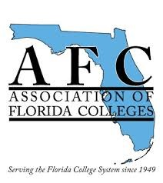
March 15, 2023

Dear Colleague:

The Association of Florida Colleges Miami Dade College Chapter would like to invite you to become a member of AFC, the professional organization for employees of the Florida College System.

As a member of AFC, you are joining other college professionals who are committed to making a difference in the lives of their students.

We also work hard to protect your interests and to promote the growth and advancement of the Florida College System and its employees. We sponsor events through Regions, Chapters and Commissions which provides members with instructional best practices. Similarly, as a member of an active and dynamic association, you will have opportunities to form valuable connections with higher educational professionals who share similar interests and goals.

According to Fund Florida Colleges, AFC has become the most inclusive higher education organization serving any college system in the nation (fundflcolleges.com). When you join AFC, you will become a member of an elite organization committed to making a difference one life at a time.

Please visit our website at www.myafchome.org to join, update your profile, select a commission, and obtain valuable information on the AFC. Please don’t forget to include your colleague’s name as your source for recruitment and remember, there’s a place for everyone in AFC!

Sincerely,

Wanda Curtiss
Statewide Membership Development Chair

