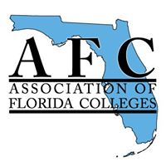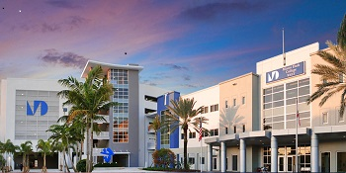
AFC West Campus
Proposal to: Jose Rodriguez, Director for CIOL Rodriguez, Jose (CT&D) <jrodri28@mdc.edu>
From: Bertha Cabrera, AFC Vice-President West Campus

Overview

AFC, the Association of Florida Colleges https://myafchome.org at West Campus is pleased to submit this proposal to CIOL in order to fulfill our goals and objectives with the Lunch & Learn Professional Development Series for this year.
We would like to take this opportunity to list the workshops that we are advertising online as well as the workshops that we want to implement on Campus at West when possible.
We sincerely appreciate your cooperation and support with this endeavor.
See list below:

Online
Class Code Class name Dates  RSK-1001-07 FERPA TBA  TWS1000-2 Technology Webinar Series: NBC Learn TBA  RSK-1000-7 Preventing Harassment on Campus TBA  lass Code |  | RSK1001-7
On Campus
Class Code | Class name | Dates
EEI 1012-2 | Food, Ethics and Sustainability | TBA
ADV1008 | College Mentoring | TBA
CED1000 | Service Learning | TBA
TWT1008-3 | Teaching with Technology: VR in the Classroom | TBA
TSS1004-2 | Emotional Regulation in the Classroom | TBA
CTD0446 | Second Language & Culture | TBA

